Name: _______________________________

Mohandas Ghandi stated, “Earth provides enough to satisfy every man’s need but not every man’s greed.” Using an example from literature, history, science, film, or your own experience or observation, write an essay analyzing the global effects of greed.

STEP 1: UNDERLINE THE TASK

STEP 2: USE R.A.F.T. TO BREAK DOWN THE PROMPT:
R
A
F
T

STEP 3: TURN THE TASK INTO A QUESTION:

______________________________________________________________________________
______________________________________________________________________________

STEP 4: ANSWER THE QUESTION—BRAINSTORM:

STEP 5: SELET THREE SUBTOPICS FROM BRAINSTORM:
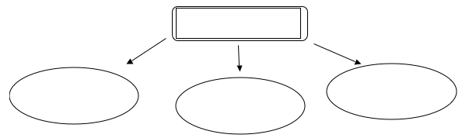

STEP 6: DEVELOP EXAMPLES:

 | SUBTOPIC FROM BRAINSTORM | EXAMPLE FROM LITERATURE, HISTORY, SCIENCE, FILM, PERSONAL EXPERIENCE | EXAMPLE FROM LITERATURE, HISTORY, SCIENCE, FILM, PERSONAL EXPERIENCE
Body Para 1
Body Para 2
Body Para 3

STEP 7: CONSTRUCT THESIS STATEMENT:

______________________________________________________________________________
______________________________________________________________________________

