Name: _______________________________

Albert Einstein once said, “Education is what remains after one has forgotten what one has learned in school.” School is not that only place to gain an education. Using examples from literature, history, science, film or your own experience, write an essay analyzing the best environment(s) to gain an education.

STEP 1: UNDERLINE THE TASK

STEP 2: USE R.A.F.T. TO BREAK DOWN THE PROMPT:
R
A
F
T

STEP 3: TURN THE TASK INTO A QUESTION:

______________________________________________________________________________
______________________________________________________________________________

STEP 4: ANSWER THE QUESTION—BRAINSTORM:

STEP 5: SELET THREE SUBTOPICS FROM BRAINSTORM:
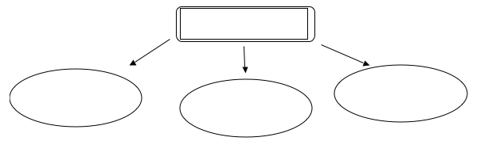

STEP 6: DEVELOP EXAMPLES:

 | SUBTOPIC FROM BRAINSTORM | EXAMPLE FROM LITERATURE, HISTORY, SCIENCE, FILM, PERSONAL EXPERIENCE | EXAMPLE FROM LITERATURE, HISTORY, SCIENCE, FILM, PERSONAL EXPERIENCE
Body Para 1
Body Para 2
Body Para 3

STEP 7: CONSTRUCT THESIS STATEMENT:

______________________________________________________________________________
______________________________________________________________________________

