**Introduction to Engineering Design (IED)**

Full Year 2014-2015

5 Credits – Practical Arts

|  |  |  |  |
| --- | --- | --- | --- |
| *Instructor:* | Mr. Giacomarra | *Classroom:* |  |
| *Phone:* |  | *Office Hours* |  |
| *E-mail* |  |

**TEXTS/RESOURCES**:

Engineering Notebook – Graph Ruled Composition book 9-3/4” x 7-1/2”,

100 sheets, sewn -no loose sheets, Staples mfg # STP-20075

Software: Autodesk Inventor Professional 2013

<http://usa.autodesk.com/>

free download available by registering on the Autodesk student community:

<http://students.autodesk.com/>

**DESCRIPTION**:

*Introduction to Engineering Design (IED)*  is for students interested in design and engineering. The major focus is to expose students to the design process, research and analysis, teamwork, communication methods, global and human impacts, engineering standards, and technical documentation. IED give students the opportunity to develop skills and understanding of course concepts through activity-, project-, and problem-based (APPB) learning. Students continually hone their interpersonal skills, creative abilities and understanding of the design process.

Students will employ engineering and scientific concepts in the solution of engineering design problems. You will use state of the art 3D solid modeling design software to help design solutions to solve proposed problems. Students will develop problem-solving skills and apply their knowledge of research and design to create solutions to various challenges that increase in difficulty throughout the course.

IED is one of three foundation courses in the Project Lead The Way high school pre-engineering program. The course applies and concurrently develops secondary level knowledge and skills in Science, Technology, Engineering and Math (STEM).

**PRE-REQUISITE**: enrolled or completed college preparatory mathematics and science.

**GOALS**:

1. Design Process
2. Modeling
3. Sketching
4. Measurement, Statistics, and Applied Geometry
5. Presentation Design and Delivery
6. 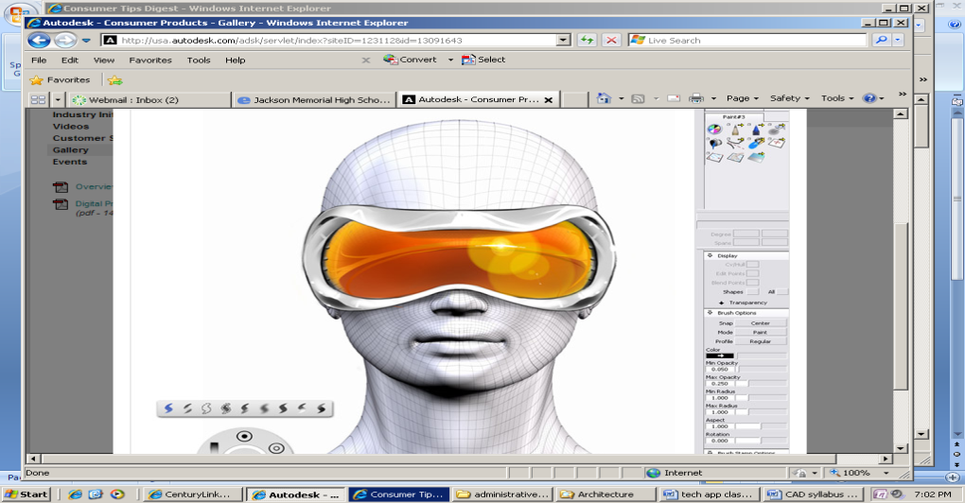Engineering Drawing Standards
7. CAD Solid Modeling
8. Reverse Engineering
9. Consumer Product Design Innovation
10. Marketing
11. Graphic Design
12. Engineering Ethics
13. Virtual Design Teams

**CREATIVITY PROJECTS**:

* Puzzle Cube.
* Toy Train.
* Reverse Engineering: Automoblox vehicles
* Virtual Design Team project

**ENGINEERING NOTEBOOK and supplies**:

* Each student is required to maintain a notebook in class to keep notes, document progress of all projects and all finished assignments**. PRINT NEATLY, all entries.**
* Bound composition book with graph paper pages.
* **Adequate supply of pencils** **with erasers**
* Notebooks will be checked/graded per marking period
* File Folder to hold worksheets, tests, loose papers, etc.

**ASSESSMENT**

Projects and assignments: 50%

Tests/Quizzes/Homework: 20%, Engineering Notebook: 10%

Class Participation/Behavior: 20%

* Grading rubrics will be provided.
* Drawings submitted > 1 day from assigned due date = minus 10 pts.

Uncompleted Assigned Drawings

* Projects must be completed and will be penalized for lateness.
* **Engineering is a demanding profession**. Get used to it!
* Students are welcome to use the computers in CAD lab after school to complete assigned drawings.

**IED (Introduction to Engineering Design)**

Course Schedule

|  |  |
| --- | --- |
| Month | TOPIC |
| Marking Period 1 | |
| September | Unit 1- Design Process  Engineering Notebook, Brainstorming - concept sketching, Product Improvement,  Discover Engineering, The Deep Dive video |
| October | Unit 2 – Technical sketching and Drawing  Techniques, Proportions, Isometrics, Oblique, Perspectives, Mulitview - Orthographic Projection. Auxiliary views.  Unit 3 – Measurement and Statistics  Linear measuring: Standard & Metric. Decimal conversions, Applied Statistics |
| Marking Period 2 | |
| November | Unit 4 – Modeling Skills  Puzzle Cube Project, Introduction to CAD: 3D modeling software. |
| December | Unit 5 – Geometry of Design  Calculating properties of shapes, Determining Density, Properties of Solids,  Physical Property Analysis. |
| January | Unit 8 – Advanced Computer Modeling  AutoCAD Inventor Parametric Modeling. Toy Train Project.  Parametric Constraints. |
| MIDTERM EXAM | |
| Marking Period 3 | |
| February | Unit 7 – Documentation  Technical Working Drawings, Dimensioning Standards, Presentation views |
| March | Unit 6 – Reverse Engineering  Visual and Functional Analysis, Product Improvement process,  Automoblox vehicles Project. |
| Marking Period 4 | |
| April & May | Unit 9 – Virtual Design Team  Application of Engineering Design Process. Communication and Documentation. Product Presentation. Product life cycle, Engineering Ethics. |
| June | Unit 10 – Design Challenges  Research/Documentation. 2nd Toy Train Car design. |
| **FINAL EXAMINATION**: Final assessments will be in two parts:  Part 1 will be an on-line PLTW assessment covering all material beginning in September, it is usually given late in May. (all students must take exam regardless of final GPA for seniors) Part 2 will be administered in June during the regular school final exam schedule.   It will consist of a student’s demonstration of practical applications of CAD software. | |

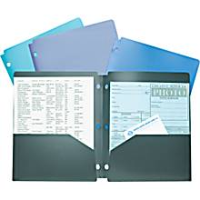Mr. Giacomarra **Engineering Class REQUIRED supplies**

1. #2 pencils and erasers (extra rubber erasers)
2. File Folder to keep handouts, tests and loose papers
3. **ENGINEERING NOTEBOOK**
   1. **1/4" graph ruled Composition notebook**
   2. **pages must be permanently "bound"**
   3. **9-3/4" x 7-1/2", 100 sheets**
   4. 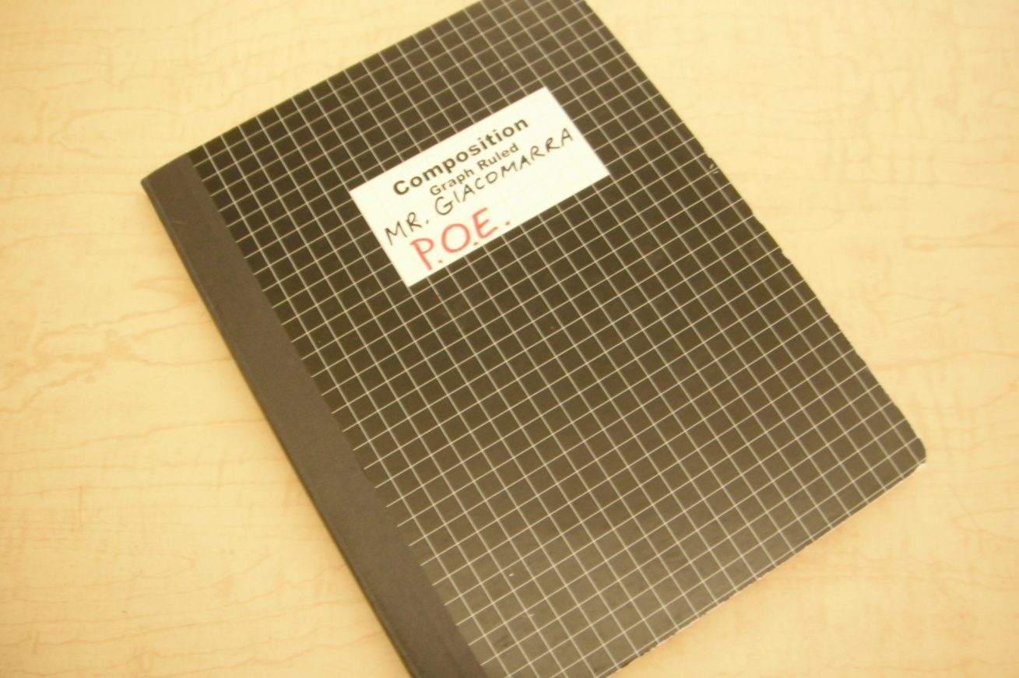**cover can be any color available**

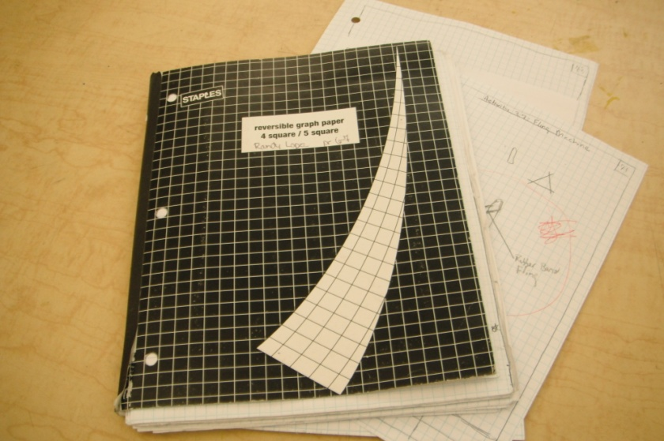

**This type of note book has "tear-out" pages and**

**is not acceptable.**

**The pages fall out and create an un-organized mess.**

Piscataway High School 2013- 2014

**CAD Lab Procedures**

Mr. Giacomarra

**Classroom Procedures & Expectations**

# BEGINNING OF CLASS PERIOD

* Be in your assigned “drafting desk” seat before the late bell.
* Place back packs under your chair or table, please do not block isles.
* Have your notebook with a **sharpened** pencil at your desk. (This is the time to sharpen pencils and have all necessary supplies).
* Remain quiet, **read and follow “DO NOW” activity written on whiteboard** in front of room.
* Be prepared to continue your classwork immediately. Your assignments are on the class calendar on your instructor’s web site.
* Only log onto computer if instructed to…do not access unauthorized web sites, or play internet games.

*PARTICIPATION IN CLASS LESSONS*

* Give teacher respect and full attention. Eyes on the teacher, not the computer.
* Use the computer only when instructed.
* Raise your hand and wait for teacher to respond if you have a question.
* Take notes.
* Participate, respect other’s ideas.
* Please stay in your seat.
* **Please allow the teacher to teach!**

*INDEPENDENT CLASSWORK and PROJECTS*

* Work on class assignments only. **CHECK CLASS CALENDAR ON TEACHER’S WEB SITE.**
* Work quietly with respect towards others.
* Collaboration and sharing ideas with classmates is encouraged to foster teamwork, and problem solving. You are responsible to complete all independent classwork on your own. Team projects, all members must share work responsibilities equally. Cheating and copy/submitting other’s work will be a zero for all students involved.

*SHIFTING GEARS and OTHER THINGS TO KNOW…*

* Sharpen your pencils before or after lessons. Please raise hand or borrow from teammate, avoid interruptions to lessons.
* Sometimes duty calls when we least expect it. Please wait until lesson is over before asking to use restroom.
* Each “drafting table” is a team. Two heads are better than one, get to know your teammate.
* Distribution of worksheets, etc. Please continue to pass along handouts to the folks seated behind or next to you .

*END OF CLASS*

* Continue to work until teacher instructs class to “clean up”.
* Return any other materials you have used. Clean up around your work area even if you did not make the mess. We will always leave our area cleaner than we found it!
* Return to your “drafting desk” with your journal.

Final “5” (last 5 things to do, last 5 minutes in class)

1. Clean up, Log off, Lock up.
2. Write down in your Engineering Notebook what you accomplished/ learned in class for the day.
3. Class discussion…volunteers to share your journal entries with class.
4. Return your journal neatly into assigned class cabinet when instructed.
5. Please wait in your assigned “drafting desk” seat until the teacher dismisses you. The “end of period bell” is only a reminder for the teacher. Upon dismissal, carefully return your chair under the desk to keep isles clear

# ABSENT FROM CLASS

* If you miss all or part of a class for any reason (illness, field trip, counselor, etc.) it is **your** responsibility to find out and make up the work missed**.**
* Ask your teammate. . Check class calendar and instructor’s website.
* Speak to teacher after class or after school. Communicate via e-mail.

# FIRE DRILL (room evacuation procedures)

* Stop whatever you are doing and leave room through main classroom door.
* Turn Right, then left. Walk to exit doors at end of main hallway on right. Stay with class.
* Upon leaving building report to designated area. Stay with class, teacher must take attendance and assure all students are accounted for.
* Return to room G104 immediately upon signal to return. Wait for Mr. G. room must be locked during drills.

# SUBSTITUTE (Mr.G. is absent)

* Please continue to demonstrate that you are my “favorite” class. Please help your substitute with attendance and procedures**.**
* Complete the assigned lesson, you will receive a project grade.
* Watch assigned video quietly, show respect to others.
* **NO USE OF COMPUTERS**

# LATE FOR CLASS

* Students are expected to bring a valid “pass” from a school administrator/ faculty member to be excused**.**
* Please reference your PHS Student Handbook for Tardiness to Class Protocol regarding unexcused lateness.

# AFTER SCHOOL “CAD PARTY” (some of you know it as “detention”)

* Report to CAD Lab room G104**.**
* If Mr. G. is not present, please wait…I never go home!
* **Smile! Mr. G. is here to help you.**

MCj02909240000[1]Piscataway High School 2013- 2014

**Lab Rules**

Mr. Giacomarra

1. TIME ON TASK

Use the complete class period to work on your CAD/Architecture/ Engineering assignment.

1. LET THE TEACHER TEACH.

Interrupting the teacher’s lesson is not fair to yourself, your classmates, and your teacher.

Please wait until after the lesson to discuss non-instruction related issues.

1. COMPUTERS ARE A TOOL

They are not provided for your entertainment.

Use only when instructed.

Access only approved software and websites.

(No email, games, videos, etc.)

Only print one/final copy of drawings/assignments. Conserve printer resources.

1. RESPECT

Yourself.

Others, their ideas, and their property.

Your teacher and school property.

Always behave in a mature appropriate manner.

Follow all Lab SAFETY RULES.

1. PERSONAL ELECTRONIC DEVICES NOT PERMITTED.

No use of cell phones, MP3 players, or any other devices.

No wearing of hats in school, you know the rules!

1. BOTTLED WATER IS PERMITTED

No food or **candy**.

Clear water only, no sports/energy drinks.

*COMMON SENSE…*

* Remain quiet. Raise your hand. Please stay seated. At end of lesson you may use restroom, go to sink, get personal items, etc. Do not spit in trash cans. Use restrooms after the lesson.
* Sit up and stay awake! Use appropriate language, no cursing.
* Please keep both of your feet and all four chair legs on the floor, thank you!

Piscataway High School - Technology Department

Mr. Giacomarra **Infraction Protocol**

No one likes to be burdened with too many rules and regulations.

Mr. Giacomarra will implement one or more of the following actions/penalties in order to reinforce to students proper behavior and respect to all, is essential in the classroom/ lab.

1. Marking Period Class Participation/ Behavior grade: (20% of marking period grade). Subtract one point per day from the total number of days class meets for a marking period. Example: class meets a total of 42 days in a marking period. Student is penalized 7 points for inappropriate behavior on 7 different days. Calculation: 35/42 * 100 = 83%. The grade of 83% will be averaged into their marking period grade along with all projects and assignments.
2. Contact student’s parents. Inform parents of student’s behavior, discuss how we will work together to resolve the problem.
3. After School Detention. Students are to report to the CAD Lab Room G104 as a punishment for their inappropriate behavior. Repeat offenses will require the student to complete an “Action Plan” where the student documents how they choose to prevent the problem from continuing.
4. Notify the student’s Assistant Principal in charge of discipline. This action will be taken after all previous attempts to work with student have not brought satisfactory results.

**Please read, complete and sign both sides of this sheet of paper.**

**RETURN THIS SHEET TO MR. GIACOMARRA**

STUDENT CONSENT AND SIGNATURE (please PRINT neatly) Date: ______________

Name: ___________________________________________________________________

Last First Middle

Grade (please circle): 9th - 10th - 11th - 12th

Class/Course Name: _________________________________________ period: _________

I have read the Course Syllabus, Class Procedures, Class Rules and Infraction Protocol and will follow them. If I ever have any questions, I will arrange to discuss them with my teacher at an agreed mutual time.

Student Signature: _________________________________________________ Date: ________

Please share with your teacher why you choose to take this class: _________________________  
______________________________________________________________________________

______________________________________________________________________________

PARENT SIGN AND CONTACT INFO

Home Phone: (___________) _________________________________

Emergency #: (___________) ______________________ Contact Name: ___________________

Father or Male Guardian's Full Name: ________________________________________________  
Day time phone number or cell: (___________) _________________________________

Mother or Female Guardian's Full Name: _______________________________________________  
Day time phone number or cell: (___________) _________________________________

Who is the preferred person to contact during school hours? _______________________________

I have read the Course Syllabus, Class Procedures, Class Rules and Infraction Protocol and have discussed them with my child.

parent/ guardian signature: _________________________________________________________

The best way to reach Mr. Giacomarra is via email: cgiacomarra@pway.org, please include a phone number in your message and he will call you if you would like. Thank you.

**ATTACHED PHOTO RELEASE FORM ON NEXT PAGE:** Please read and sign where applicable if you agree or do not agree to consent.

**PISCATAWAY TOWNSHIP SCHOOLS**

**CONSENT TO PUBLISH CLIENT INFORMATION AND RELEASE**

In an effort to promote achievements of Piscataway Township Schools,

I, (Name of Parent/Guardian) __________________________ give permission for Piscataway School officials to interview or photograph my child in connection with any publication (including, but not limited to: annual report, newsletter, brochures and video tapes; local newspapers, television, print advertisements or electronic print advertisements, such as Piscataway website or Internet or Rutgers University newspaper and/or website), in such manner, at such times, and in such media as Piscataway shall determine.

I release Piscataway Township Schools from any liability arising out of Piscataway's use and publication of the information.

________________________________________

name of child

________________________________________ ________________

Signature of Parent/Guardian Date

________________________________________ ________________

Signature of Witness Date

*****************************************************************

**DO NOT CONSENT TO PUBLISH CLIENT INFORMATION AND RELEASE**

________________________________________

name of child

________________________________________ ________________

Signature of Parent/Guardian Date