Name: _______________________________

Eleanor Roosevelt once said, “In the long run, we shape our lives, and we shape ourselves. The process never ends until we die. And the choices we make are ultimately our own responsibility.” Choices shape our lives in many ways. Using examples from literature, history, science, film or your own experience, write an essay explaining how choice can shape a persons life in a positive way.

STEP 1: UNDERLINE THE TASK

STEP 2: USE R.A.F.T. TO BREAK DOWN THE PROMPT:
R
A
F
T

STEP 3: TURN THE TASK INTO A QUESTION:

______________________________________________________________________________
______________________________________________________________________________

STEP 4: ANSWER THE QUESTION—BRAINSTORM:

STEP 5: SELET THREE SUBTOPICS FROM BRAINSTORM:
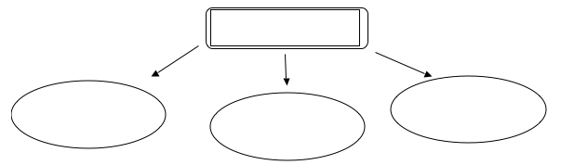

STEP 6: DEVELOP EXAMPLES:

 | SUBTOPIC FROM BRAINSTORM | EXAMPLE FROM LITERATURE, HISTORY, SCIENCE, FILM, PERSONAL EXPERIENCE | EXAMPLE FROM LITERATURE, HISTORY, SCIENCE, FILM, PERSONAL EXPERIENCE
Body Para 1
Body Para 2
Body Para 3

STEP 7: CONSTRUCT THESIS STATEMENT:

______________________________________________________________________________
______________________________________________________________________________

