Name: _______________________________

In The Crime of Sylvester Bonnard, French writer Anatole France writes, “To know is
nothing at all; to imagine is everything.” Why might one argue that imagination is more
valuable than facts? Using an example from literature, history, science, film, or your own
experience or observation, write an essay analyzing the worth of imagination.

STEP 1: UNDERLINE THE TASK

STEP 2: USE R.A.F.T. TO BREAK DOWN THE PROMPT:
R
A
F
T

STEP 3: TURN THE TASK INTO A QUESTION:

______________________________________________________________________________
______________________________________________________________________________

STEP 4: ANSWER THE QUESTION—BRAINSTORM:

STEP 5: SELET THREE SUBTOPICS FROM BRAINSTORM:
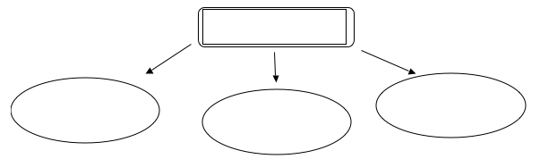

STEP 6: DEVELOP EXAMPLES:

 | SUBTOPIC FROM BRAINSTORM | EXAMPLE FROM LITERATURE, HISTORY, SCIENCE, FILM, PERSONAL EXPERIENCE | EXAMPLE FROM LITERATURE, HISTORY, SCIENCE, FILM, PERSONAL EXPERIENCE
Body Para 1
Body Para 2
Body Para 3

STEP 7: CONSTRUCT THESIS STATEMENT:

______________________________________________________________________________
______________________________________________________________________________

