Name: _______________________________

William Arthur Ward once said, “Forgiveness is a funny thing. It warms the heart and cools the sting.” Using examples from literature, history, film, current events, or personal experience, write an essay explaining why it is important to forgive.

STEP 1: UNDERLINE THE TASK

STEP 2: USE R.A.F.T. TO BREAK DOWN THE PROMPT:
R
A
F
T

STEP 3: TURN THE TASK INTO A QUESTION:

______________________________________________________________________________
______________________________________________________________________________

STEP 4: ANSWER THE QUESTION—BRAINSTORM:

STEP 5: SELET THREE SUBTOPICS FROM BRAINSTORM:
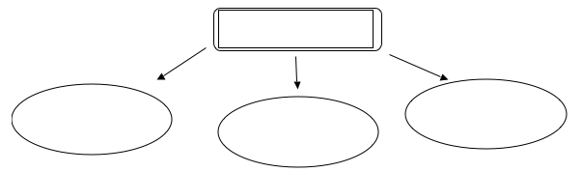

STEP 6: DEVELOP EXAMPLES:

 | SUBTOPIC FROM BRAINSTORM | EXAMPLE FROM LITERATURE, HISTORY, SCIENCE, FILM, PERSONAL EXPERIENCE | EXAMPLE FROM LITERATURE, HISTORY, SCIENCE, FILM, PERSONAL EXPERIENCE
Body Para 1
Body Para 2
Body Para 3

STEP 7: CONSTRUCT THESIS STATEMENT:

______________________________________________________________________________
______________________________________________________________________________

